Running multiple versions of Microsoft Access and security issues.
Marine Recorder (the application) ships with Access 2003 runtime so you do not need a copy of Access on your machine to use it.

Multiple versions of Access
However, all the additional tools (snapshot, Reporting etc) really require that you have a full version of Access. This can be 2000 or later with 2010 being the current version.
If you have multiple versions of Access installed on your machine any MDB that you click on will open with the last version of Access that you used. This can be irritating, but the work around is to open the version of Access you want and then open the MDB from there. You can always create yourself a shortcut if you are opening a particular MDB regularly.
You may also see Access saying its “installing” itself as you switch between versions – its not really – its just changing its registry settings etc to the current version you are opening – but again this can be irritating – phone Microsoft – or visit something like http://www.fmsinc.com/products/startup/ if it bothers you more than $500 !

Avoiding Microsoft security errors with Marine Recorder
Microsoft have locked down access as there is a risk that an unknown MDB (or word document or excel spreadsheet etc) could do something malicious to your system. The risk is obviously dependant on whether you open files from unknown sources.
By default Microsoft Access will block running of all macros on all mdbs – which will mean nothing will run and you will see a message like:
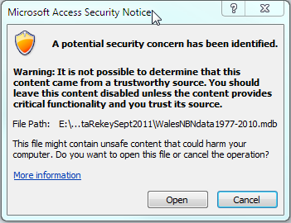
Clicking open is required repeatedly (once for each linked table)
Note: If you are running on a domain you may need to speak with your network manager as some of these options may not be available as they can also be controlled at domain level and you will need to speak to your support staff for the best solution.

A better solution is to goto File, Info Options:
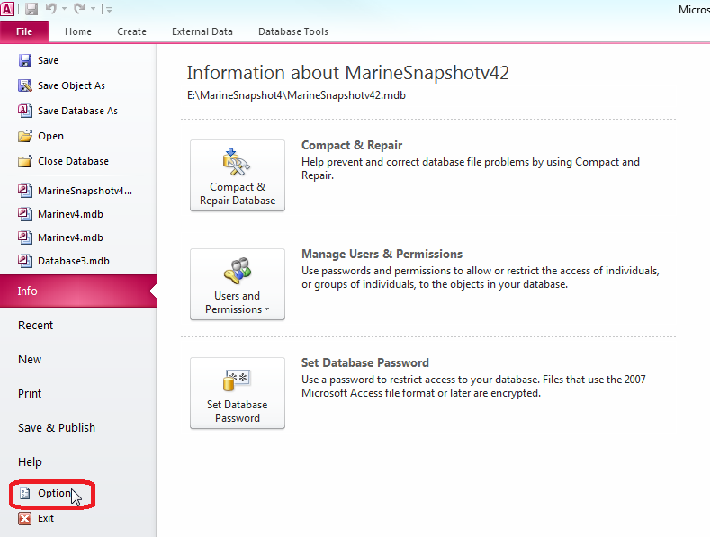
And then: Trust Center, Macros Settings and enable all macros. (If you are running on a locked down network you may need to consult you network manager before being allowed to make this change).
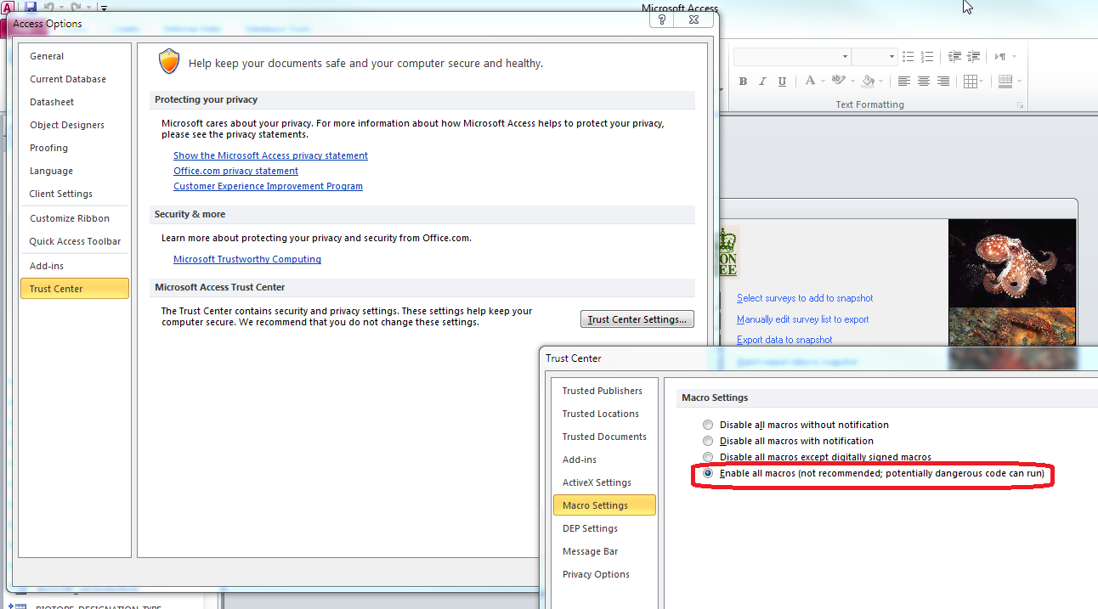

An alternative solution to granting permission to all macros (if you feel this may be insecure in your setup), you can alternatively make the locations where MarineRecorder and its data files are stored trusted locations. This means they will run without warnings – even if macros are disabled.
NOTE: You need to make sure that the locations of any linked databases are also included in the trusted locations (e.g. your NBNDATA.MDB)
